v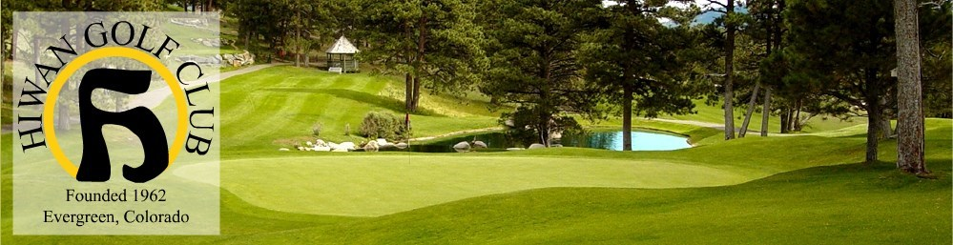

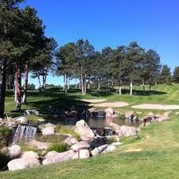 | EVERGREEN ELKS LODGE #2363  ^{Date:} CHARITY GOLF TOURNAMENT  MONDAY, JUNE 17, 2024 $175 per player  ALL PROCEEDS BENEFIT LOCAL CHARITY  Greens Fees, Cart, Range, Lunch—Prizes and Fun  (NEW TIME) 6:30 Registration, 8:00 Shotgun Start Four Player Scramble Best ball - Longest/Closest/Betting Holes THOUSAND$ in prizes  Lunch & Awards Presentation & Prize Drawings at Hiwan Golf Club to follow tournament  Get your foursome together. Sign up today! Space is
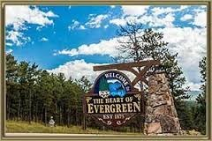 | limited! Singles welcome  Registration Bill Downes (303)880-9880  Credit cards Connie (303) 674-5591 Ext 12  EMAIL: ElksatHiwan@aol.com Larry De Cicco  Checks: Evergreen Elks #2363, PO Box 298, Evergreen, CO 80437  Proper country club attire: collared shirt, no jeans
2024 ELKS CHARITY TOURNAMENT @HIWAN
JUNE 17, 2024 - Preregistration highly recommended
Free Elks Lodge Happy Hour drink card to pay by June 13, 2024
PLAYERS FOURSOMES $700 INDIVIDUALS $175

AMOUNT PAID $______________
Credit Cards: Call Connie (303)674-5591 Ext 12
Checks to Evergreen Elks Lodge #2363
PO Box 298, Evergreen, CO 80437
Questions? Registration: Bill Downes (303)880-9880
Tournament: Larry De Cicco Cell (303)489-4399

TEAM NAME_______________________________
TEAM LEADER _____________________________
1. NAME ____________________________________
PHONE___________________________________
EMAIL____________________________________
2. NAME_____________________________________
PHONE____________________________________
EMAIL____________________________________
3. NAME_____________________________________
PHONE____________________________________
EMAIL_____________________________________
4. NAME______________________________________
PHONE_____________________________________
EMAIL_____________________________________

6 ft. String, per player $30 at check in - Prepay $25 (by 6/13)

